Lab 9-1 Modeling a Value-Based Partition
Goals | To model a value-based partition.
Scenario | ABC wants to implement separate partitions for customer data. One partition will store data for customers A – M, the other will store data for customers  N – Z.
Outcome | In the Physical layer, new physical sources custAtoM and custNtoZ.  In the Logical layer, changed sources for Customers.
Time | 15 – 20 minutes
Environment | 
Instructions:
- Examine the current results with all customer data in one source.
  - If necessary, start the Siebel Analytics Server service.
  - Start Siebel Analytics Web and log in as Administrator with no password.
  - Click the Answers link.
  - Click the SupplierSales subject area.
  - Select Customers.Customer, SalesFacts.Dollars, and SalesFacts.Units Shipped and click the Results tab.
  - Record the name of the first customer in the list:
  - Click the last record button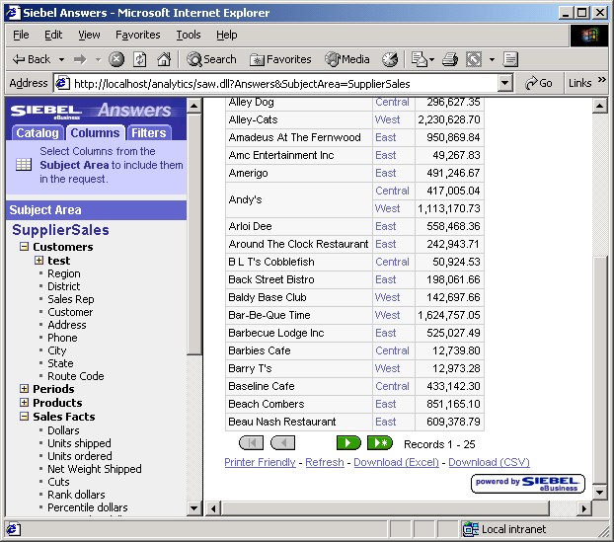 to move to the end of the list.
  - Record the total number of customers in the list:
  - Select File > Close to exit Siebel Answers.
- Assume the role of the data base administrator (DBA) and create the new partitioned customer tables using Microsoft Query Analyzer.
  - Select Start > Programs > Microsoft SQL Server > Query Analyzer.
  - Log in as sa with no password.
  - Select supplier2 from the drop-down list to enter the supplier2 database:
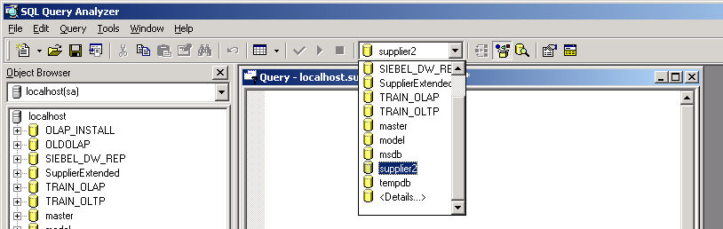
  - Create the partitions using SQL. Type the following SQL in the window and click the green arrow icon to run it:
Note: Case is important.
Select * into supplier2..D1_custAtoM from supplier2..D1_customer2 where Name < ‘N’
Select * into supplier2..D1_custNtoZ from supplier2..D1_customer2 where Name >= ‘N’
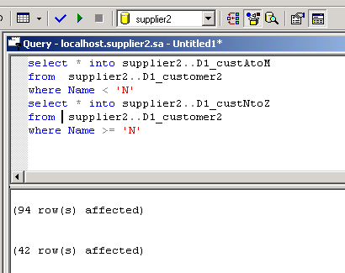
  - Select File > Exit and click No to close the application.
- Open the repository file.
  - Shut down the Siebel Analytics Server service.
  - Double-click C:\SiebelAnalytics\Repository\abc.rpd to open the repository. Log in as Administrator with no password.
- Create the Physical layer in the repository to reference the new partitioned tables.
  - Import the sources D1_custAtoM and D1_custNtoZ into the Physical layer:
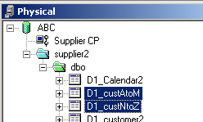
  - Click the Physical Diagram and New foreign key icons to create the physical joins from the new customer tables to the D1_Orders2 table. The customer tables are on the one side of the one-to-many relationships. The joins use NewKey to CustKey.
  - Check your work:
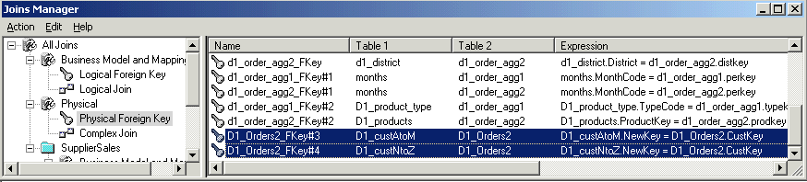
- Change the business model to use the new partitions instead of the original source.
  - In the Physical layer, drag D1_custAtoM to Customers in the Business Model and Mapping layer.
  - Delete the following logical columns since they are duplicates and not needed: NewKey, Name, and SalesRep.
  - Double-click D1_custAtoM in the Sources folder and select the Content tab.
  - Click the ellipsis button to open the Fragmentation Content expression builder.
  - Select Logical Tables, Customers, and double-click Customer.
  - Click < and type ‘N’.
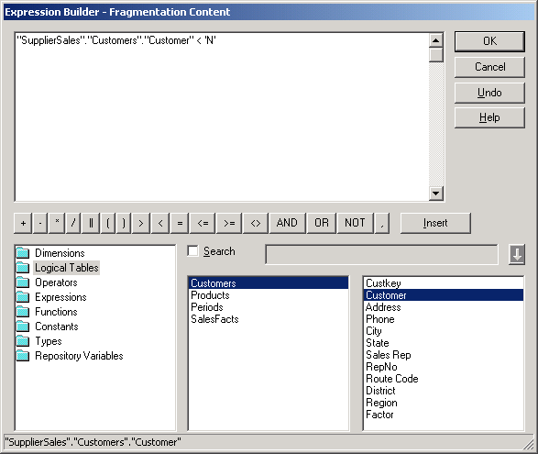
  - Click OK.
  - Check This source should be combined with others at this level.
  - Select the Column Mapping tab and modify the mappings as follows:
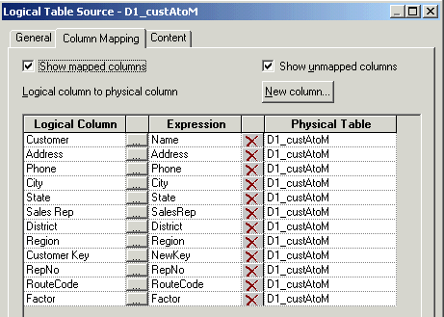
  - Click OK.
  - In the Physical layer, drag D1_custNtoZ to Customers in the Business Model and Mapping layer.
  - Delete the following logical columns since they are duplicates and not needed: NewKey, Name, and SalesRep.
  - Double-click D1_custNtoZ in the Sources folder and select the Content tab.
  - Click the ellipsis button to open the Fragmentation Content expression builder.
  - Select Logical Tables, Customers, and double-click Customer.
  - Click >= and type ‘N’.
  - Click OK.
  - Check This source should be combined with others at this level.
  - Select the Column Mapping tab and modify the mappings as follows:
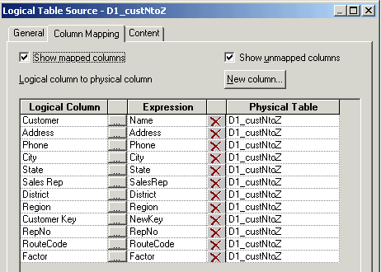
  - Click OK.
  - Deactivate the original source by double-clicking D1_customer2, selecting the General tab, and unchecking the Active flag.
  - Click OK.
  - Notice that you did not have to change the Presentation layer.
- Select File > Check Global Consistency to validate your work.
- Select File > Save to save your work.
- Select File > Exit to close the Administration Tool.
- Restart the Siebel Analytics Web service.
- Test your results.
  - Start the Siebel Analytics Server service.
  - Start Siebel Analytics Web and log in as Administrator with no password.
  - Click the Answers link.
  - Click the SupplierSales subject area.
  - Select Customers.Customer, SalesFacts.Dollars, and SalesFacts.Units Shipped and select the Results tab.
  - Compare your results to those in step 1. There should not be any difference.
- Verify that the query being issued is accessing your new tables.
  - Double-click C:\SiebelAnalytics\Log\NQQuery.log.
  - Scroll to the end of the file.
  - Scroll backwards to locate the last select statement.
  - Verify that it references your new tables:
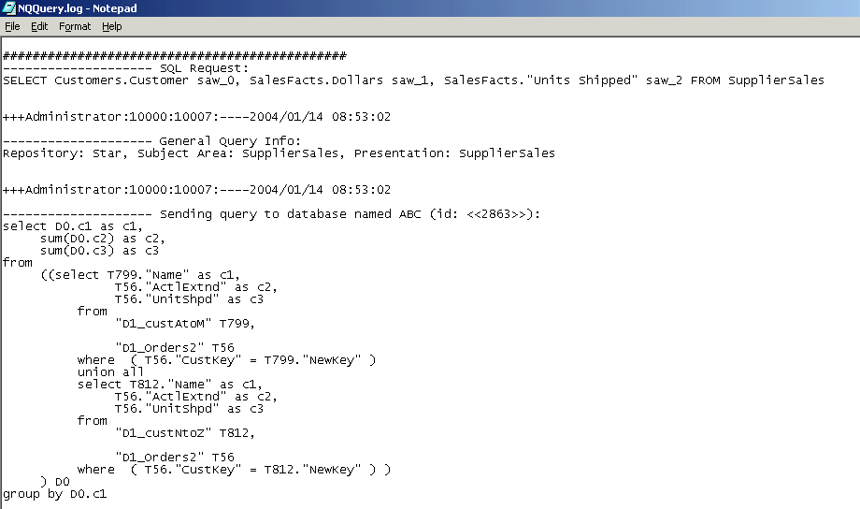
  - Select File > Exit to close the log file.
- Further test that your results are correct for names >= N:
  - Return to Answers and add a filter to Customer to show names greater than N:
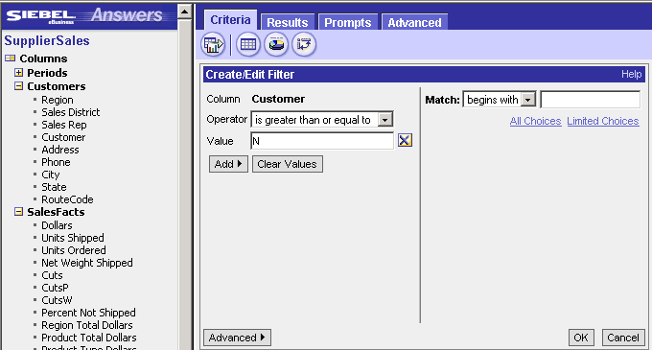
  - Run the query.
  - Verify that your results display names starting with N and above:
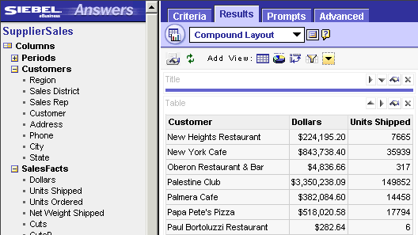
  - Verify that the query being issued is accessing the correct partition.
    - Double-click C:\SiebelAnalytics\Log\NQQuery.log.
    - Scroll to the end of the file.
    - Scroll backwards to locate the select statement.
    - Verify that only the N to Z partition is being used:
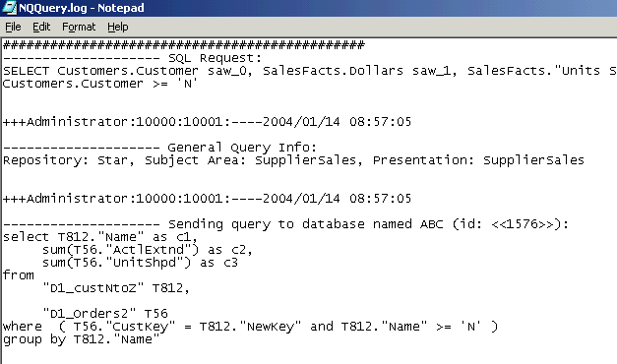
  - Select File > Exit to close the log file.
- Further test that your results are correct for names < N.
  - Return to Answers and change the filter to show names less than N:
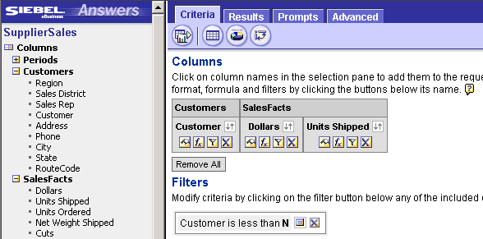
  - Run the query.
  - Verify that your results display names less than N.
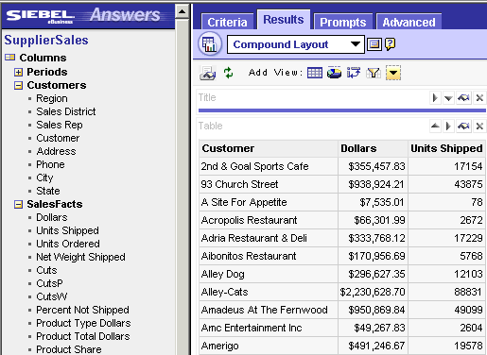
  - Verify that the query being issued is accessing the correct partition:
    - Double-click C:\SiebelAnalytics\Log\NQQuery.log.
    - Scroll to the end of the file.
    - Scroll backwards to locate the select statement.
    - Verify that only the A to M partition is being used:
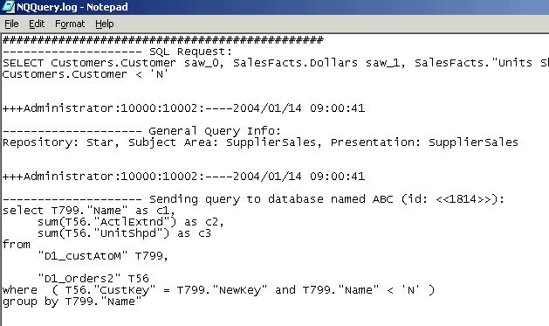
  - Select File > Exit to close the log file.
  - Select File > Close to exit Siebel Answers.
Solutions 9-1 Modeling a Value-Based Partition
Answers
1.f. Record the name of the first customer in the list:
2nd & Goal Sports Cafe
1.h. Record the total number of customers in the list:
134

